Racial progress manipulation (Wilkins, Hirsch, Kaiser & Inkles, 2016: Study 2)

In 1965, the student of color (Black and Latino) population at Wesleyan was 5%. At this time, a group of Wesleyan economists designed a study to predict the racial progress that a progressive liberal arts institution such as Wesleyan would experience through each decade. To do this, they took into account evolving demographics and other societal conditions.

Low progress
One measure of progress that they investigated was student of color enrollment, which they projected to be 34% in 2010. The Wesleyan student body was 11% students of color (Black and Latino) in 2010.

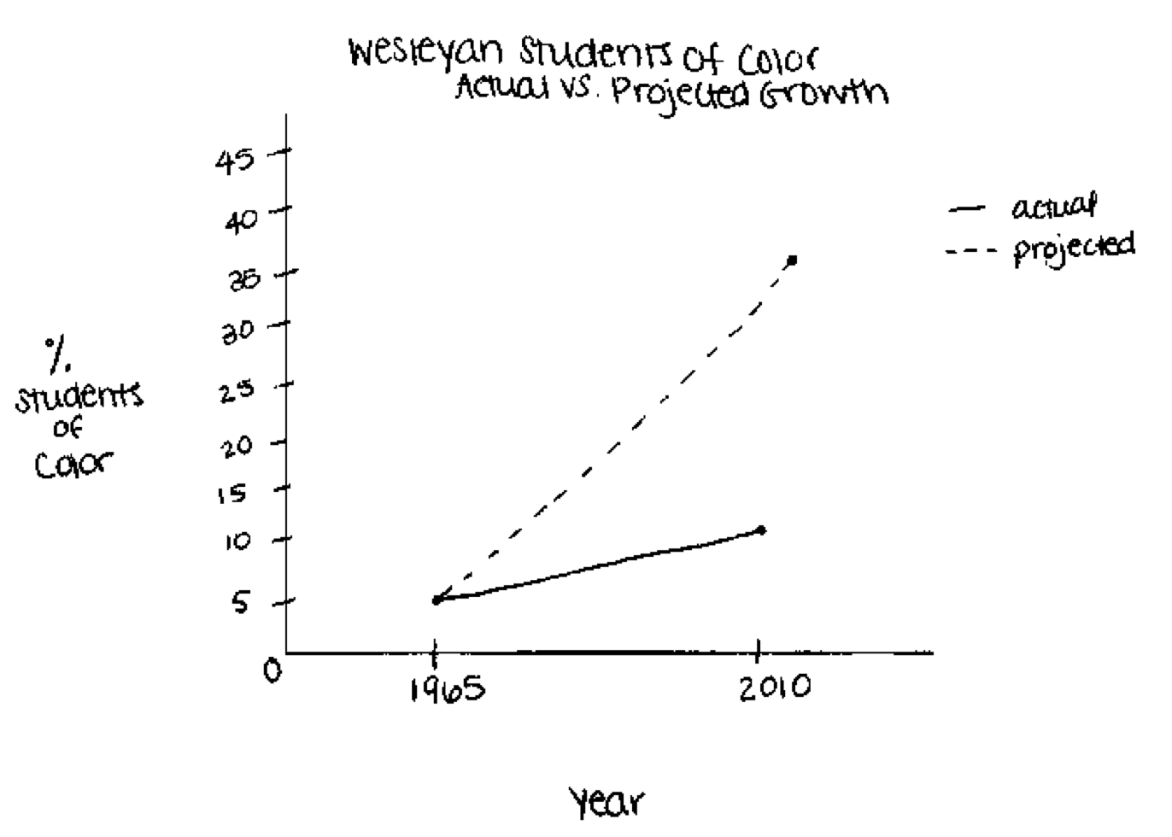
High progress
One measure of progress that they investigated was student of color enrollment, which they projected to be 11% in 2010. The Wesleyan student body was 34% students of color (Black and Latino) in 2010.

